Empathize and Discover

|  |  |
| --- | --- |
| Date | 15 october 2022 |
| Team ID | PNT2022TMID36938 |
| Project | Smart fashion recommender application |
| Maximum mark | 4 |

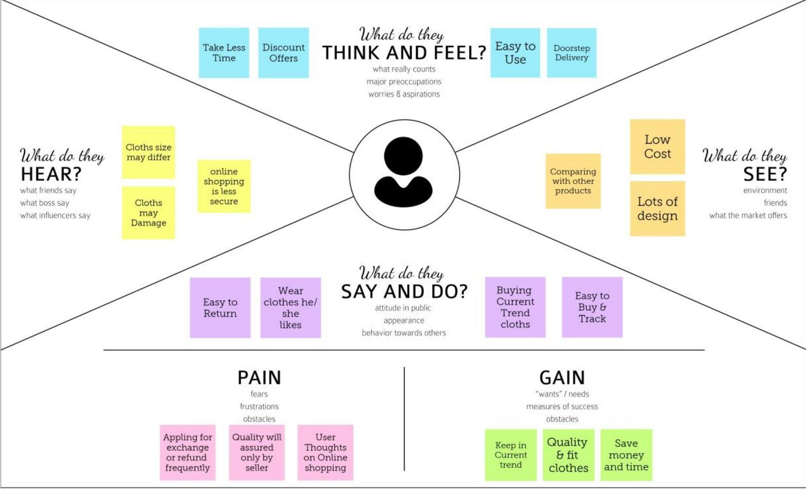

EMPATHIZE MAP BY

AAISHA.M

HEMALATHA.S

KAVIYA.D

HARINI.R

SAVITHA.S